Purpose
The purpose of this document is to detail how the Geost algorithm works.

Scope
This document covers all input and output of the Geost setup verification algorithm. For application functions, see the application specification.

Definitions
Identity matrix | An identity matrix is matrix used as a multiplier to mask specific values from another matrix, an example of this is shown below:  $$\left[\begin{matrix}10 & 10 & 100 & 10 & 80 & 100 \\ 5 & 50 & 250 & 250 & 10 & 20 \\ 8 & 200 & 255 & 255 & 200 & 10 \\ 9 & 200 & 255 & 255 & 200 & 30 \\ 3 & 10 & 250 & 250 & 4 & 40 \\ 10 & 30 & 15 & 18 & 20 & 0\end{matrix}\right]*\left[\begin{matrix}0 & 0 & 0 & 0 & 0 & 0 \\ 0 & 0 & 1 & 1 & 0 & 0 \\ 0 & 1 & 1 & 1 & 1 & 0 \\ 0 & 1 & 1 & 1 & 1 & 0 \\ 0 & 0 & 1 & 1 & 0 & 0 \\ 0 & 0 & 0 & 0 & 0 & 0\end{matrix}\right]=\left[\begin{matrix}0 & 0 & 0 & 0 & 0 & 0 \\ 0 & 0 & 250 & 250 & 0 & 0 \\ 0 & 200 & 255 & 255 & 200 & 0 \\ 0 & 200 & 255 & 255 & 200 & 0 \\ 0 & 0 & 250 & 250 & 0 & 0 \\ 0 & 0 & 0 & 0 & 0 & 0\end{matrix}\right]$$  In the above example, the matrix on the left are the pixel values where inner is highlighted in blue and outer is left white, this matrix is dot-multiplied by the matrix on the right to show how only the inner values remain and the outer values return to zero.

Component Design

Setup Verification (Calibration)
There are a number of components that are used and shared by other larger components these are defined first.

checkCalibration22
checkCalibration22 is an integral method of the setup verification process. This function is implemented in MATLAB code. This section serves as a guide to the MATLAB code; however greater details can be derived by looking at the code comments within the file.

Purpose
This function is used to verify that an input image taken using the device probe is within acceptable bounds (tested to produce expected results) of brightness, exposure, and gain settings. The algorithm compares the input image to a “baseline” image generated by averaging hundreds of perfect calibration images together. The generation of a baseline image is described in the Baseline Image Set Creator section.
The input image is compared against the baseline image on a pixel-by-pixel basis and as a whole. These values must meet the configuration restrictions passed in as parameters along with the input image (described below).
As detailed by the Baseline Image Set Creator, images are mapped to 4 regions. An identity matrix is used to calculate passing or failing pixels for each region. These four regions are:
- Inner – the inner circle below the probe which appears mostly black.
- Outer – the region beyond the plasma which appears mostly black.
- Corona – the “fingering” section of the corona which appears to have little lightning bolts fingering out from the center.
- High Plateau – the brightest part of the image between the fingering corona and the inner ring, this is the peak of the corona.

Inputs
The checkCalibration22 function accepts parameters to perform its calculations on:
- imageBaselineSetFile – the baseline CData.mat file which is an output from Baseline Image Set Creator detailed below.
- IUTFile – a single setup verification image file location.
- sigmaRegions –the maximum flat absolute value difference of a pixel from the baseline allowed for a pixel to pass.
- threshRegions –the percent of failures within a region that would cause the overall image to fail.
- binDepth – the size of the block of pixels binned together while searching for clumps of bright pixels indicating a dirty glass electrode surface.
- sigmaMeans – the number of standard deviations away from the baseline image that indicate a failure.
- useIm2EllitCenter – if true, use the same algorithm as the coefficient analysis to find the center of the image input image; if false, use Canny method of edge detection.

Outputs
The variable names below are named after the exact usage within the .mat code file used in MATLAB.
- status –a single digit value indicating that the image has passed or failed calibration.
- stat –a structured array with the following data:
- matFail – a vector with 6 elements indicating the count of failed pixels, that is failed pixels in inner, outer, corona, high plateau, failed clumps, and total failures.
- matTotal – a vector containing the total number of pixels in each region.
- percentFail – the percent of failures within each of the 6 regions.
- stdFail – vector of 6 elements indicating the status of each tested region determined by comparing the percentFail of each region with the threshold value from the threshRegions input.
- meanFail – vector with 4 elements indicating the status of each tested region determined by comparing the difference between the mean of each region and the threshold input values.
- meanDiff – vector with 4 elements indicating the difference in the mean value of the input image and the baseline image.
- output – Stores various output information used for debugging:
- IUT – the input image returned as an output.
- currDiffImage – the difference image created by taking the input image pixels and subtracting the baseline.
- idxFailO, idxFailI, idxFailC, idxFailH – listed as separate variables, these are the identity mapping of the failed pixels for each of the 4 regions.
- aveIntensityO, aveIntensityI, aveIntensityC, aveIntensityH, aveIntensity – the average intensity of each of the 4 regions and the overall total.
- currStddevImagebin – the input image binned using the depth specified. This is the result of the binImageNorm function described below.
- idxFailClumps – failed clumps in the binned image identified using the sigmaRegions for pixels too far from the baseline; this indicates the exact bin clumps in the image that failed in a matrix the size of the input image divided by the input binDepth.

Function
The setup verification process begins by capturing a new image using the calibration probe on the device or by a privileged user loading a previous image.
The image is passed into the checkCalibration22 function where each pixel is read into a matrix the same size of the image. The “brightness” of the pixel is determined using a single dimension (R, G or B) of the three dimensional array illustrated by the matrices below:
$$\left[\begin{aligned}R=\left|\begin{matrix}R_{11} & … & R_{1n} \\ ⋮ & ⋱ & ⋮ \\ R_{m1} & … & R_{mn}\end{matrix}\right| \\ G=\left|\begin{matrix}G_{11} & … & G_{1n} \\ ⋮ & ⋱ & ⋮ \\ G_{m1} & … & G_{mn}\end{matrix}\right| \\ B=\left|\begin{matrix}B_{11} & … & B_{1n} \\ ⋮ & ⋱ & ⋮ \\ B_{m1} & … & B_{mn}\end{matrix}\right|\end{aligned}\right]$$
Since the image is grayscale, R, G, B should be exactly the same.
The baseline data file is loaded for later use.
The first task is to center the input image so that it may accurately be compared to the baseline image. Canny edge detection (Everyone, 2013) is used to find the inner edge. The widest and smallest points are then measured and the center point of the ellipse is calculated. The image is transposed to the absolute center of the baseline image. The Coefficient Analysis algorithm for finding the center can also be used when the last flag (useIm2EllitCenter) is set to true, or 1.
Each pixel in the image is compared to corresponding pixel of the baseline image, allowing for a variance of a specified number of standard deviations (default is 2). When a pixel falls outside the specified number of standard deviations, it is counted as a failure. Failures are counted for each region, and the overall total failures.
The mean difference is calculated by subtracting the baseline average and the input image. All pixel values in the region are averaged to produce an overall region average. The region average is compared to the meanMeanBase defined in 4.2.4.4 to determine if the region overall fails because its average value is outside the number of standard deviations specified by the input sigmaMeans.
The image is then binned using the binDepth, in order to find clumps of unusual (not matching the average) pixels. This process uses standard square binning, e.g. when binDepth is 4, the image is split in to a grid of 4x4 pixels, 16 pixels in each block of the grid. The 16 pixels in each block are averaged together to create one value called a clump. If this value is outside the number of standard deviations defined by the sigmaRegions input, the clump fails.
Finally, the results are tallied and returned to the ClearView application in a COM object. The MATLAB library reinterprets the COM object as a .NET data type and they are stored in the database for later reference.

BinImageNorm
BinImageNorm is a standard binning algorithm that takes an input image, and a binDepth. An image with a binDepth of 4 is divided into 4x4 blocks of pixels. All 16 pixels are averaged together to create a single value per block of pixels. The result is a matrix that is the size of the input image divided by the binDepth for both X and Y dimensions.

Baseline Image Set Creator
Baseline Image Set Creator is a tool used to blend “perfect” calibration images into one average image. The image is then analyzed pixel-by-pixel and the standard deviation, median, and range are determined per-pixel. This tool allows the ClearView setup verification algorithm to determine if a new input image fits within acceptable criteria derived from the blended “perfect” image. The output of this tool is a simple .mat file called CDATA.mat. This file contains all the variables necessary to filter out input calibration images as described below.

Purpose
The purpose of this tool is to provide an easy to use interface for manipulating a large matrix that describes a 320 x 240 pixel bitmap. The tool loads a set of any number of images and finds the average, standard deviation, and aggregate values for the entire set. It optionally displays a tool for moving the region definitions which translate into 4 identity matrices stored in the CData.mat file. These processes can be done manually but it would take a huge amount of time.

Inputs
“Directory of Training Data” – the directory from which to load setup verification images to be used in blending calculations.
Automatic segmentation (option) – if true, automatically distributes the regions and displays an edit dialog for creating region identities; if false, the region alignment figure is displayed and the regions can be moved and resized as shown in 4.2.4.3.

Outputs
Image Baselines Set File – average and standard deviation information for each pixel, identity matrices describing each region, and overall region averages and standard deviations.

Function
The primary display is a dialog which allows the directory of images to be selected and a checkbox for automatically selecting the 4 regions:
- Inner – the inner circle below the probe which appears mostly black.
- Outer – the region beyond the plasma which appears mostly black.
- Corona – the “fingering” section of the corona which appears to have little lightning bolts fingering out from the center.
- High Plateau – the brightest part of the image between the fingering corona and the inner ring, this is the peak of the corona.

The number of setup verification images to be loaded is displayed.
The status of what calculation or aggregate data is being generated is displayed at the bottom of the dialog.

Input Window
The main display for loading calibration images is shown below:
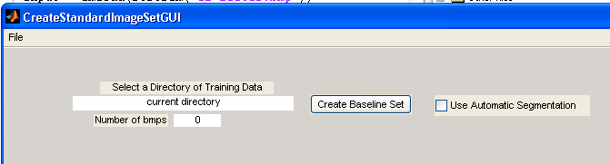
The File menu can be selected to choose a specific directory or exit the dialog:
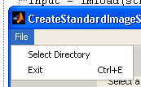
Once the directory full of images to blend is selected, the user clicks “Create Baseline Set”. The images are processed, the status it updated with each step along the way, and output windows are shown.

Output Windows
Various outputs are displayed as the images are processed in order to view the resulting average and standard deviation values. This list is not comprehensive as many windows are repetitive information but segmented for each region.
When the calculations are complete the resulting average image and standard deviations are displayed:
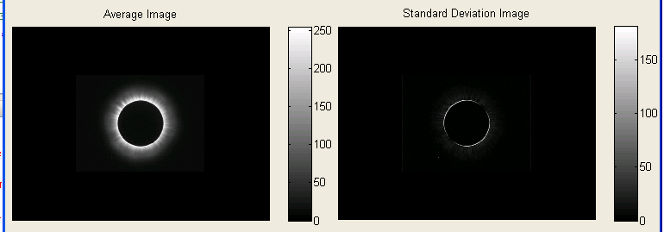
This is the average image constructed from averaging each individual pixel from each of the input images.
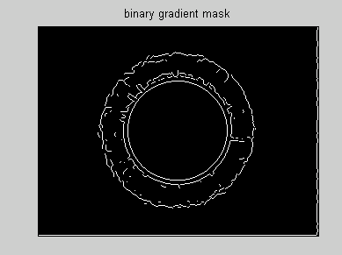
This window displays the lines between each region with the edges highlighted.
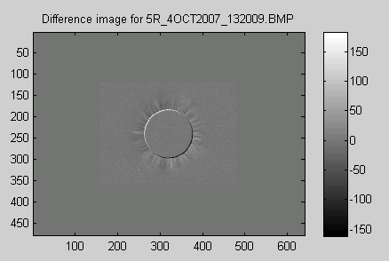
One of the images from the input set subtracted from the average image.
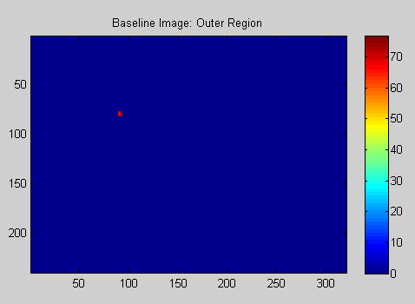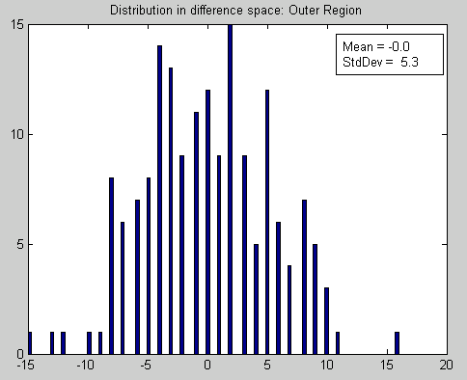
Intensity distribution for each region is shown.

Region Alignment
If automatic segmentation is left unchecked, the user is presented with a dialog for adjusting the region layout.
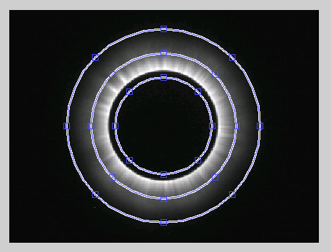
Each point can be selected and moved to generate an identity matrix for each region. Here is an example of the output from the process for the inner region:
$$Inner= \left[\begin{matrix}0 & 0 & 0 & 0 & 0 & 0 \\ 0 & 0 & 1 & 1 & 0 & 0 \\ 0 & 1 & 1 & 1 & 1 & 0 \\ 0 & 1 & 1 & 1 & 1 & 0 \\ 0 & 0 & 1 & 1 & 0 & 0 \\ 0 & 0 & 0 & 0 & 0 & 0\end{matrix}\right]$$

CData.mat Format
The final output of the baseline image set creator is a MATLAB serialized binary file. This file is renamed to CData.mat to be loaded by ClearView.
idxRegionsL – Contains the four region identity matrices.
imageBaselineSet – Contains the baseline image information split into the following name-value pairs:
averageImageL – The input images averaged together per pixel.
stderrImageL – The standard deviation of the input images per pixel.
meanMeanBase – A total mean of all pixels in the region.
stdMeanBase – The standard deviation of all pixels in a region across all input images.

References
Application Requirements

